**JUnit Test Report**

First of all, the target against this testing is the Method called “scanList” in my MinActivity . This unit test is to test whether the target method returns correct ArrayList.

After the first testing, the error occurs. The details as follow:

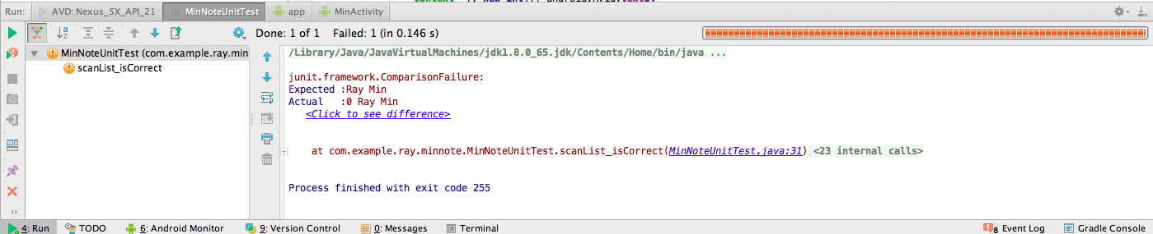

It turns out that I forgot to delete the information “ID”, which is a kind of testing technique I always use, from “title” in each Note. It happens a lot cause I do not have a good testing habit, which is I should work on next.

After the second testing, there is no error. The details as follow:

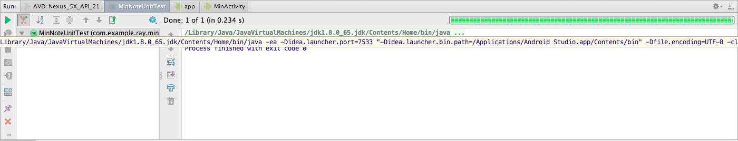

The testing coverage as shown in following screen shot:

